Lab Guide 2

Pods:
Q.1 Create a Pod using quay.io/mayank123modi/myhttpd image and name of POD should be pod1.
Q.2 Create a Pod using quay.io/mayank123modi/mynginx image and name of POD should be pod2.
Q.3 Create a Pod using yaml method, and use quay.io/mayank123modi/mynginx image and name of POD should be yamlpod1.
Q.4 Create a Pod using yaml method, and use quay.io/mayank123modi/myserver image and name of POD should be yamlpod2

Ans: 1

oc run pod1 --image quay.io/mayank123modi/myhttpd
oc get pods

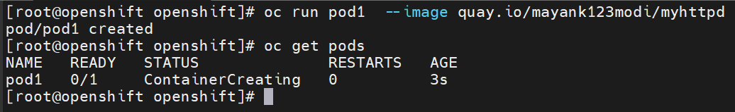

Ans: 2
Oc run pod2 --image nginx
oc get pods pod2

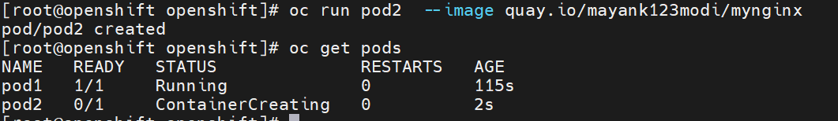

Ans 3:

oc run yamlpod1 --image nginx --dry-run -o yaml
oc run yamlpod1 --image nginx --dry-run -o yaml > pod1.yaml
cat pod1.yaml
oc create -f pod1.yaml
oc get pods

Ans: 4
oc run yamlpod2 --image mdhack/myserver --dry-run -o yaml
oc run yamlpod2 --image mdhack/myserver --dry-run -o yaml > pod2.yaml
cat pod2.yaml
oc create -f pod2.yaml
oc get pods

Clean up your Environment

oc delete all --all –force
oc get pods

